MongoDB server advanced 9

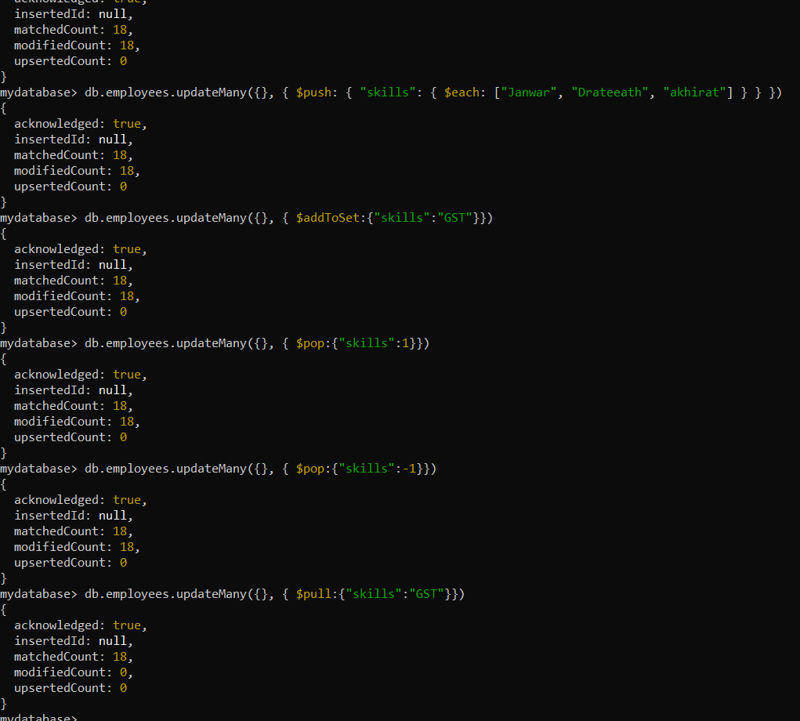

**Codes: ASE Data analyst(Engr Ajman ullah khan)**

db.employees.find({Location:"Pakistan"})

[

{

_id: 1,

firstName: 'Haris',

lastName: 'Khan',

email: 'jamilking345@gmail.com',

salary: 85000,

skills: [ 'Angular', 'React', 'MongoDB' ],

department: { name: 'IT' },

Location: 'Pakistan'

},

{

_id: 2,

firstName: 'Haris',

lastName: 'Khan',

email: 'sachin.t@abc.com',

salary: 85000,

skills: [ 'Accounting', 'Tax' ],

department: { name: 'Finance' },

Location: 'Pakistan'

},

{

_id: 3,

firstName: 'Haris',

lastName: 'Khan',

email: 'jamesb@abc.com',

salary: 85000,

skills: [ 'Sales', 'Marketing' ],

department: { name: 'Marketing' },

Location: 'Pakistan'

},

{

_id: 4,

firstName: 'Haris',

lastName: 'Khan',

email: 'steve.j@abc.com',

salary: 85000,

Location: 'Pakistan'

},

{

_id: 5,

firstName: 'Haris',

lastName: 'Khan',

email: 'kapil.d@abc.com',

salary: 85000,

skills: [ 'Accounting', 'Tax' ],

department: { name: 'Finance' },

Location: 'Pakistan'

},

{

_id: 6,

firstName: 'Haris',

lastName: 'Khan',

email: 'amitabh.b@abc.com',

salary: 85000,

Location: 'Pakistan'

},

{

_id: ObjectId("635cbabc1bc43a2866caf655"),

firstName: 'Haris',

lastName: 'Khan',

email: 'waqasahmat234@gmail.com',

salary: 85000,

Location: 'Pakistan'

},

{

_id: ObjectId("635cbaf81bc43a2866caf656"),

firstName: 'Haris',

lastName: 'Khan',

email: 'ZubairAli675@gmail.com',

salary: 85000,

Location: 'Pakistan'

},

{

_id: ObjectId("635cbb8d1bc43a2866caf657"),

firstName: 'Haris',

lastName: 'Khan',

email: 'HassanAli875@gmail.com',

salary: 85000,

Location: 'Pakistan'

},

{

_id: ObjectId("635cbbd21bc43a2866caf658"),

firstName: 'Haris',

lastName: 'Khan',

email: 'ajman41288@gmail.com',

salary: 85000,

Location: 'Pakistan'

},

{

_id: ObjectId("635cbbf91bc43a2866caf659"),

firstName: 'Haris',

lastName: 'Khan',

email: 'Zohranaseem@gmail.com',

salary: 85000,

Location: 'Pakistan'

},

{

_id: ObjectId("635cc2380ac0ff7a169fad1a"),

firstName: 'Haris',

lastName: 'Khan',

email: 'john.king@abc.com',

salary: 85000,

skills: [ 'Angular', 'React', 'MongoDB' ],

department: { name: 'IT' },

Location: 'Pakistan'

},

{

_id: ObjectId("635cc2bf0ac0ff7a169fad1f"),

firstName: 'Haris',

lastName: 'Khan',

email: 'john.king@abc.com',

salary: 85000,

skills: [ 'Angular', 'React', 'MongoDB' ],

department: { name: 'IT' },

Location: 'Pakistan'

},

{

_id: ObjectId("635cc2bf0ac0ff7a169fad20"),

firstName: 'Haris',

lastName: 'Khan',

email: 'sachin.t@abc.com',

salary: 85000,

skills: [ 'Accounting', 'Tax' ],

department: { name: 'Finance' },

Location: 'Pakistan'

},

{

_id: ObjectId("635cc2bf0ac0ff7a169fad21"),

firstName: 'Haris',

lastName: 'Khan',

email: 'jamesb@abc.com',

salary: 85000,

skills: [ 'Sales', 'Marketing' ],

department: { name: 'Marketing' },

Location: 'Pakistan'

},

{

_id: ObjectId("635cc2bf0ac0ff7a169fad22"),

firstName: 'Haris',

lastName: 'Khan',

email: 'steve.j@abc.com',

salary: 85000,

Location: 'Pakistan'

},

{

_id: ObjectId("635cc2bf0ac0ff7a169fad23"),

firstName: 'Haris',

lastName: 'Khan',

email: 'kapil.d@abc.com',

salary: 85000,

skills: [ 'Accounting', 'Tax' ],

department: { name: 'Finance' },

Location: 'Pakistan'

},

{

_id: ObjectId("635cc2bf0ac0ff7a169fad24"),

firstName: 'Haris',

lastName: 'Khan',

email: 'amitabh.b@abc.com',

salary: 85000,

Location: 'Pakistan'

}

]

mydatabase> db.employees.updateMany({Location:"Pakistan"},{$inc:{salary:10000}})

{

acknowledged: true,

insertedId: null,

matchedCount: 18,

modifiedCount: 18,

upsertedCount: 0

}

mydatabase> db.employees.find({Location:"Pakistan"})

[

{

_id: 1,

firstName: 'Haris',

lastName: 'Khan',

email: 'jamilking345@gmail.com',

salary: 95000,

skills: [ 'Angular', 'React', 'MongoDB' ],

department: { name: 'IT' },

Location: 'Pakistan'

},

{

_id: 2,

firstName: 'Haris',

lastName: 'Khan',

email: 'sachin.t@abc.com',

salary: 95000,

skills: [ 'Accounting', 'Tax' ],

department: { name: 'Finance' },

Location: 'Pakistan'

},

{

_id: 3,

firstName: 'Haris',

lastName: 'Khan',

email: 'jamesb@abc.com',

salary: 95000,

skills: [ 'Sales', 'Marketing' ],

department: { name: 'Marketing' },

Location: 'Pakistan'

},

{

_id: 4,

firstName: 'Haris',

lastName: 'Khan',

email: 'steve.j@abc.com',

salary: 95000,

Location: 'Pakistan'

},

{

_id: 5,

firstName: 'Haris',

lastName: 'Khan',

email: 'kapil.d@abc.com',

salary: 95000,

skills: [ 'Accounting', 'Tax' ],

department: { name: 'Finance' },

Location: 'Pakistan'

},

{

_id: 6,

firstName: 'Haris',

lastName: 'Khan',

email: 'amitabh.b@abc.com',

salary: 95000,

Location: 'Pakistan'

},

{

_id: ObjectId("635cbabc1bc43a2866caf655"),

firstName: 'Haris',

lastName: 'Khan',

email: 'waqasahmat234@gmail.com',

salary: 95000,

Location: 'Pakistan'

},

{

_id: ObjectId("635cbaf81bc43a2866caf656"),

firstName: 'Haris',

lastName: 'Khan',

email: 'ZubairAli675@gmail.com',

salary: 95000,

Location: 'Pakistan'

},

{

_id: ObjectId("635cbb8d1bc43a2866caf657"),

firstName: 'Haris',

lastName: 'Khan',

email: 'HassanAli875@gmail.com',

salary: 95000,

Location: 'Pakistan'

},

{

_id: ObjectId("635cbbd21bc43a2866caf658"),

firstName: 'Haris',

lastName: 'Khan',

email: 'ajman41288@gmail.com',

salary: 95000,

Location: 'Pakistan'

},

{

_id: ObjectId("635cbbf91bc43a2866caf659"),

firstName: 'Haris',

lastName: 'Khan',

email: 'Zohranaseem@gmail.com',

salary: 95000,

Location: 'Pakistan'

},

{

_id: ObjectId("635cc2380ac0ff7a169fad1a"),

firstName: 'Haris',

lastName: 'Khan',

email: 'john.king@abc.com',

salary: 95000,

skills: [ 'Angular', 'React', 'MongoDB' ],

department: { name: 'IT' },

Location: 'Pakistan'

},

{

_id: ObjectId("635cc2bf0ac0ff7a169fad1f"),

firstName: 'Haris',

lastName: 'Khan',

email: 'john.king@abc.com',

salary: 95000,

skills: [ 'Angular', 'React', 'MongoDB' ],

department: { name: 'IT' },

Location: 'Pakistan'

},

{

_id: ObjectId("635cc2bf0ac0ff7a169fad20"),

firstName: 'Haris',

lastName: 'Khan',

email: 'sachin.t@abc.com',

salary: 95000,

skills: [ 'Accounting', 'Tax' ],

department: { name: 'Finance' },

Location: 'Pakistan'

},

{

_id: ObjectId("635cc2bf0ac0ff7a169fad21"),

firstName: 'Haris',

lastName: 'Khan',

email: 'jamesb@abc.com',

salary: 95000,

skills: [ 'Sales', 'Marketing' ],

department: { name: 'Marketing' },

Location: 'Pakistan'

},

{

_id: ObjectId("635cc2bf0ac0ff7a169fad22"),

firstName: 'Haris',

lastName: 'Khan',

email: 'steve.j@abc.com',

salary: 95000,

Location: 'Pakistan'

},

{

_id: ObjectId("635cc2bf0ac0ff7a169fad23"),

firstName: 'Haris',

lastName: 'Khan',

email: 'kapil.d@abc.com',

salary: 95000,

skills: [ 'Accounting', 'Tax' ],

department: { name: 'Finance' },

Location: 'Pakistan'

},

{

_id: ObjectId("635cc2bf0ac0ff7a169fad24"),

firstName: 'Haris',

lastName: 'Khan',

email: 'amitabh.b@abc.com',

salary: 95000,

Location: 'Pakistan'

}

]

mydatabase> db.employees.find({Location:"Pakistan"},{$max:{salary:{}}})

MongoServerError: FieldPath field names may not start with '$'. Consider using $getField or $setField.

mydatabase> db.employees.find({_id:5})

[

{

_id: 5,

firstName: 'Haris',

lastName: 'Khan',

email: 'kapil.d@abc.com',

salary: 95000,

skills: [ 'Accounting', 'Tax' ],

department: { name: 'Finance' },

Location: 'Pakistan'

}

]

mydatabase> db.employees.updateOne({_id:5},{$set:{email:"Hariskhan564@gmail.com"}})

{

acknowledged: true,

insertedId: null,

matchedCount: 1,

modifiedCount: 1,

upsertedCount: 0

}

mydatabase> db.employees.find({_id:5})

[

{

_id: 5,

firstName: 'Haris',

lastName: 'Khan',

email: 'Hariskhan564@gmail.com',

salary: 95000,

skills: [ 'Accounting', 'Tax' ],

department: { name: 'Finance' },

Location: 'Pakistan'

}

]

mydatabase> db.employees.updateMany({_id:5},{$set:{skills:["DataAnalyst PythonDeveloper"]}})

{

acknowledged: true,

insertedId: null,

matchedCount: 1,

modifiedCount: 1,

upsertedCount: 0

}

mydatabase> db.employees.find({_id:5})

[

{

_id: 5,

firstName: 'Haris',

lastName: 'Khan',

email: 'Hariskhan564@gmail.com',

salary: 95000,

skills: [ 'DataAnalyst PythonDeveloper' ],

department: { name: 'Finance' },

Location: 'Pakistan'

}

]

mydatabase> db.employees.updateMany({_id:5},{$set:{department:{name:"Computer and Software Engineering"}}})

{

acknowledged: true,

insertedId: null,

matchedCount: 1,

modifiedCount: 1,

upsertedCount: 0

}

mydatabase> db.employees.find({_id:5})

[

{

_id: 5,

firstName: 'Haris',

lastName: 'Khan',

email: 'Hariskhan564@gmail.com',

salary: 95000,

skills: [ 'DataAnalyst PythonDeveloper' ],

department: { name: 'Computer and Software Engineering' },

Location: 'Pakistan'

}

]

mydatabase> db.employees.updateMany({skills:"DataAnalyst"},{$set:{"skills.$":"Public-Speaking"}})

{

acknowledged: true,

insertedId: null,

matchedCount: 0,

modifiedCount: 0,

upsertedCount: 0

}

mydatabase> db.employees.find({_id:5})

[

{

_id: 5,

firstName: 'Haris',

lastName: 'Khan',

email: 'Hariskhan564@gmail.com',

salary: 95000,

skills: [ 'DataAnalyst PythonDeveloper' ],

department: { name: 'Computer and Software Engineering' },

Location: 'Pakistan'

}

]

mydatabase> db.employees.updateMany({skills:"DataAnalyst PythonDeveloper"},{$set:{"skills.$":"Public-Speaking"}})

{

acknowledged: true,

insertedId: null,

matchedCount: 0,

modifiedCount: 0,

upsertedCount: 0

}

mydatabase> db.employees.updateMany({},{$set:{"skills.$[element]":"DataAnalyst"}},{arrayFilters:[{element:"PublicSpeaking"}]})

MongoServerError: The path 'skills' must exist in the document in order to apply array updates.

mydatabase> db.employees.updateMany({},{$posh:{skills:"Sports"}})

MongoServerError: Unknown modifier: $posh. Expected a valid update modifier or pipeline-style update specified as an array

mydatabase> db.employees.updateMany({},{$push:{skills:"Sports"}})

{

acknowledged: true,

insertedId: null,

matchedCount: 18,

modifiedCount: 18,

upsertedCount: 0

}

mydatabase> db.employees.updateMany({},{$push:{skills:"Education"}})

{

acknowledged: true,

insertedId: null,

matchedCount: 18,

modifiedCount: 18,

upsertedCount: 0

}

mydatabase> db.employees.updateMany({},{$push:{skills:"Country"}})

{

acknowledged: true,

insertedId: null,

matchedCount: 18,

modifiedCount: 18,

upsertedCount: 0

}

mydatabase> db.employees.updateMany({},{$push:{skills:"Visa"}})

{

acknowledged: true,

insertedId: null,

matchedCount: 18,

modifiedCount: 18,

upsertedCount: 0

}

mydatabase> db.employees.find({skills:"DataAnalyst"})

mydatabase> db.employees.updateMany({},{$push:{"skills":{$each:["IT","DataEngineer","DataSystem"]}}})

{

acknowledged: true,

insertedId: null,

matchedCount: 18,

modifiedCount: 18,

upsertedCount: 0

}

mydatabase> db.employees.updateMany({},{$push:{"skills":{$each:["Zindagi","Death","Islam"]}}}

mydatabase> db.employees.updateMany({},{$push:{"skills":{$each:["Zindagi","Death","Islam"]}}})

{

acknowledged: true,

insertedId: null,

matchedCount: 18,

modifiedCount: 18,

upsertedCount: 0

}

mydatabase> db.employees.updateMany({}, { $push: { "skills": { $each: ["Janwar", "Drateeath", "akhirat"] } } })

{

acknowledged: true,

insertedId: null,

matchedCount: 18,

modifiedCount: 18,

upsertedCount: 0

}

mydatabase> db.employees.updateMany({}, { $addToSet:{"skills":"GST"}})

{

acknowledged: true,

insertedId: null,

matchedCount: 18,

modifiedCount: 18,

upsertedCount: 0

}

mydatabase> db.employees.updateMany({}, { $pop:{"skills":1}})

{

acknowledged: true,

insertedId: null,

matchedCount: 18,

modifiedCount: 18,

upsertedCount: 0

}

mydatabase> db.employees.updateMany({}, { $pop:{"skills":-1}})

{

acknowledged: true,

insertedId: null,

matchedCount: 18,

modifiedCount: 18,

upsertedCount: 0

}

mydatabase> db.employees.updateMany({}, { $pull:{"skills":"GST"}})

{

acknowledged: true,

insertedId: null,

matchedCount: 18,

modifiedCount: 0,

upsertedCount: 0

}

mydatabase>

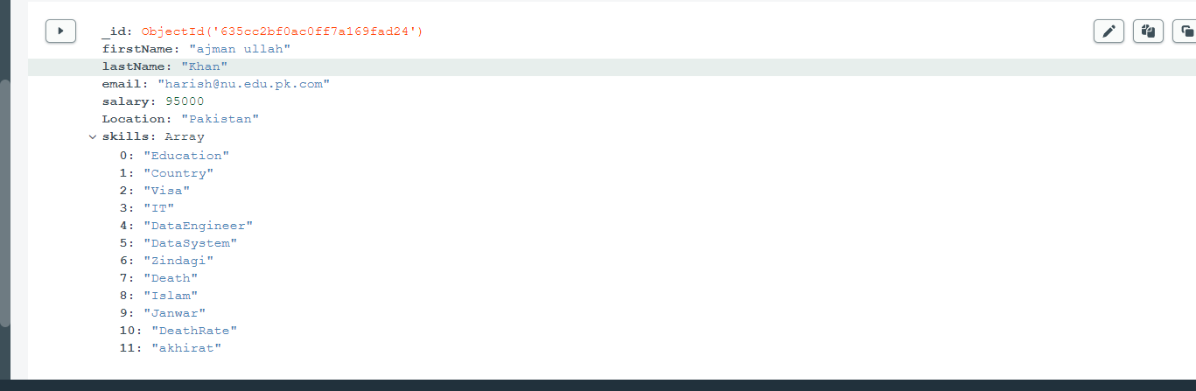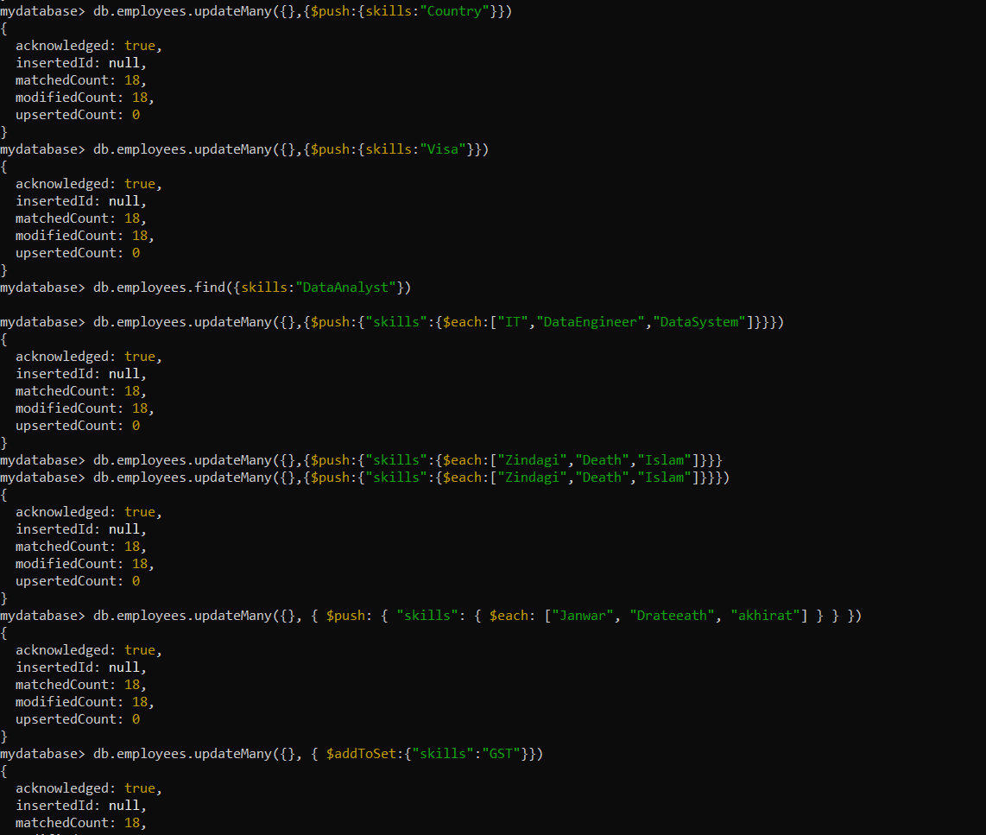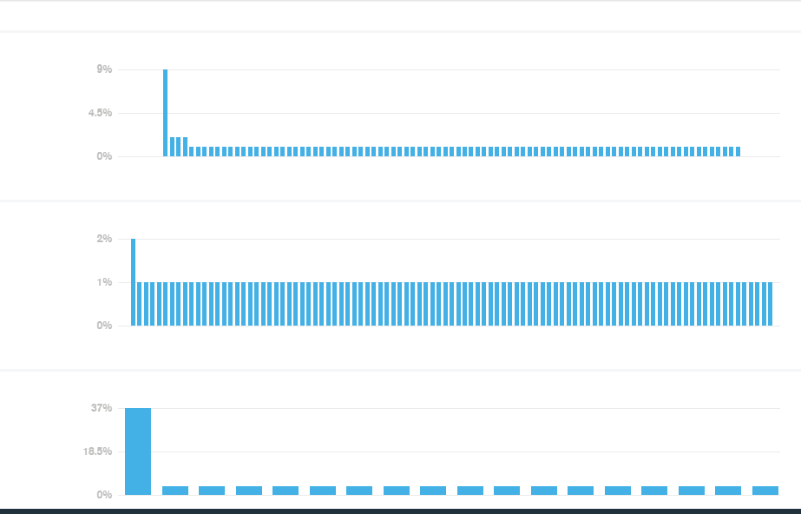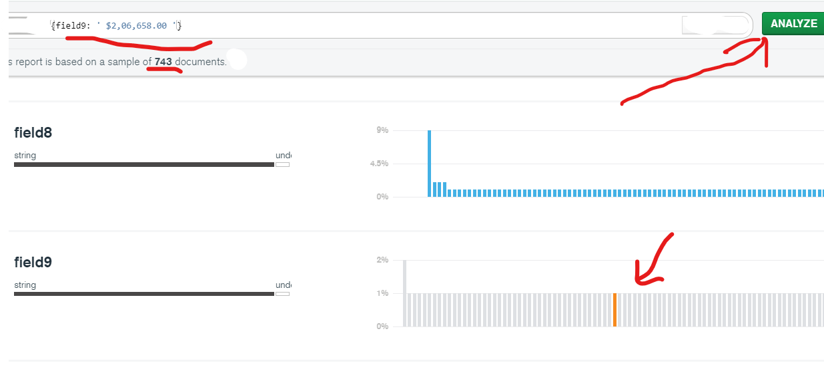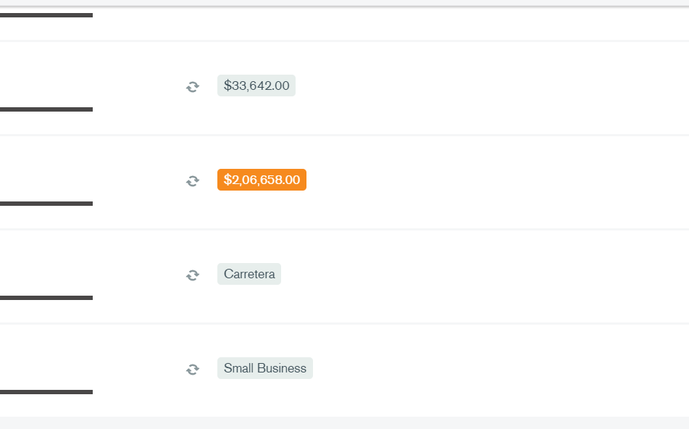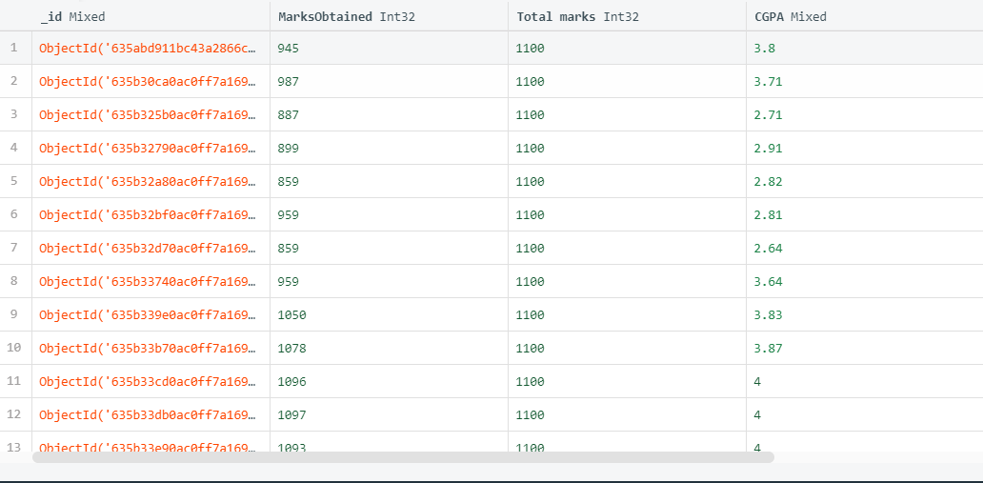

***** End ***